2. Write a AngularJS Program to binding and perform Expressions Using ng-bind?
Sol: In index.html file do write the following HTML code
<!DOCTYPE html>
<html>

<head>
<title>ng-bind Directive</title>

<script src=
"https://ajax.googleapis.com/ajax/libs/angularjs/1.6.9/angular.min.js">
</script>
</head>

<body ng-app="gfg" style="text-align:center">

<h1 style="color:green">Multiplication</h1>
<h2>ng-bind Directive</h2>

<div ng-controller="app">
num1: <input type="number" ng-model="num1"
ng-change="product()" />
<br><br>

num2: <input type="number" ng-model="num2"
ng-change="product()" />
<br><br>

<b>Product:</b> <span ng-bind="result"></span>
</div>

<script>
var app = angular.module("gfg", []);
app.controller('app', ['$scope', function ($app) {
$app.num1 = 1;
$app.num2 = 1;
$app.product = function () {
$app.result = ($app.num1 * $app.num2);
}
}]);
</script>
</body>

</html>

Output:
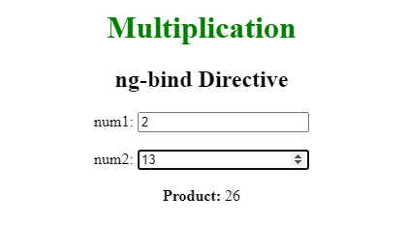
3. AngularJS Program using AngularJS Directives
Sol: In index.html file do write the following HTML code
<!doctype html>
<html>
<head>
<script src = "http://ajax.googleapis.com/ajax/libs/angularjs/1.5.2/angular.min.js">
</script>
</head>

<body ng-app = "myapp">

<div ng-controller = "HelloController">
<h2>Welcome {{helloTo.title}} to PACE CSE Students!</h2>
</div>

<script>
angular.module("myapp", [])
.controller("HelloController", function($scope) {
$scope.helloTo = {};
$scope.helloTo.title = "AngularJS";
});
</script>
</body>
</html>

Output:
4. Example Program to Create Table and display content in the table
Sol: In app.js file change the code as follows
var app=angular.module("mytableapp",[]);
app.controller("mytablecontroller",function($scope){
$scope.students=[
{StudentRollNo:1,StudentName:"Kailash",Class:"1 std"},
{StudentRollNo:2,StudentName:"Sudhir",Class:"1 std"},
{StudentRollNo:3,StudentName:"Pankaj",Class:"2 std"},
{StudentRollNo:4,StudentName:"Panxi",Class:"2 std"},
{StudentRollNo:5,StudentName:"Praban",Class:"3 std"},
{StudentRollNo:6,StudentName:"Praphul",Class:"3 std"},
]
});

In index.html file do write the following HTML code
<HTML ng-app = "myapp">
<TITLE> AngularJS Learning(anchoScroll)</TITLE>
<script src="https://ajax.googleapis.com/ajax/libs/angularjs/1.5.6/angular.min.js"></script>
<script>
var myapp=angular.module("myapp",[]);
myapp.filter('displayPageData', function() {
return function(input, start) {
start = +start; //parse to int
return input.slice(start);
}
});
myapp.controller("myappcont",function($scope){
$scope.currentPage = 0;

$scope.students=[
{Name:"Kailash",Gender:"Male",Class:"1Std",Section:"A"},
{Name:"Kalyan",Gender:"Male",Class:"1Std",Section:"A"},
{Name:"Kalyani",Gender:"Female",Class:"1Std",Section:"A"},
{Name:"Kamal",Gender:"Male",Class:"2Std",Section:"B"},
{Name:"Keshav",Gender:"Male",Class:"2Std",Section:"B"},
{Name:"KedarGouri",Gender:"Female",Class:"2Std",Section:"B"},
];
});

</script>
<BODY ng-controller="myappcont">
<table border="1" style="width:80%">
<caption>
<h2>Student List</h2>
</caption>
<thead>
<tr>
<th>Name</th>
<th>Gender</th>
<th>Class</th>
<th>Section</th>
</tr>
</thead>
<tbody>
<tr ng-repeat="student in students">
<td>{{student.Name}}</td>
<td>{{student.Gender}}</td>
<td>{{student.Class}}</td>
<td>{{student.Section}}</td>
</tr>
</tbody>
</table>
</BODY>
</HTML>

Output:
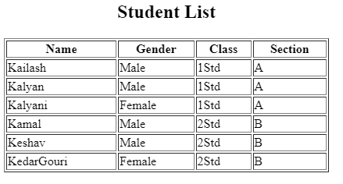
5. Write a program to creation of form and Validation of form on submit?
Sol: In index.html file do write the following HTML code
<!DOCTYPE html>
<html>
<head>

<meta chrset="UTF 8">
<title>Event Registration</title>
</head>

<body ng-app="sampleApp">
<script src="https://code.angularjs.org/1.6.9/angular-route.js"></script>
<script src="https://code.angularjs.org/1.6.9/angular.min.js"></script>
<script src="https://code.angularjs.org/1.6.9/angular.js"></script>
<script src="lib/bootstrap.js"></script>
<script src="lib/bootstrap.css"></script>
<h1> Guru99 Global Event</h1>
<div ng-controller="AngularController">

<form>
&nbsp;&nbsp;&nbsp;&nbsp;
Enter your user name:
<input type="text" name="name" required><br><br>&nbsp;&nbsp;&nbsp;

Enter your password:&nbsp;&nbsp;&nbsp;
<input type="password"/><br><br>&nbsp;&nbsp;&nbsp;

Enter your email:&nbsp;&nbsp;&nbsp;&nbsp;&nbsp;&nbsp;&nbsp;&nbsp;
<input type="email"/><br><br>&nbsp;&nbsp;&nbsp;

Enter your age:&nbsp;&nbsp;&nbsp;&nbsp;&nbsp;&nbsp;&nbsp;&nbsp;&nbsp;&nbsp;&nbsp;
<input type="number" /><br><br>&nbsp;&nbsp;&nbsp;&nbsp;&nbsp;&nbsp;&nbsp;&nbsp;&nbsp;

<input type="submit" value="Submit"/>
</form>
</div>

</body>
</html>

Output:
